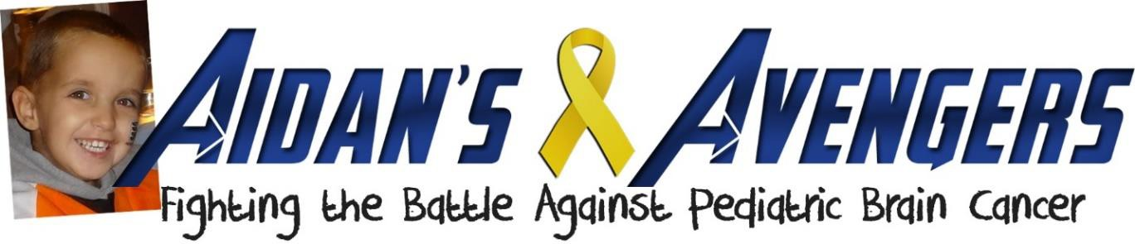

YOU can help us reach our 2022 goal of $20,000 for Pediatric Brain Cancer Research with our NEW

If you would like to help us reach our goal, please consider participating in our
“Sponsor A Superhero” Program.

This program gives you the opportunity to help us raise even more funds toward our mission of finding a cure for Pediatric Brain Cancer (especially DIPG) and Family Support.

When registering as a runner or walker, you'll be given the option to Create a Fundraiser Page online. You can also use the attached sponsor form and submit your sponsors/donations the morning of the race.

September is Childhood Cancer Awareness month – Go Gold!! This is a great time to get family, friends, teammates, co-workers, etc. involved in your fight against Pediatric Brain Cancer (the most deadly form of Childhood Cancer) and ask them to sponsor your SUPERHERO efforts at the Superhero 5K and Walk.

As a thank you for your fundraising efforts, registered/paying participants can receive the following INCENTIVE PRIZES! Participants only qualify for one incentive level based on total fundraising (excluding initial race registration fees) as of Saturday, October 1st. All prizes will have Aidan’s Avengers name/logo.

Level 1 – Raise $100 – Receive a $15 Aidan’s Avengers Gift Certificate Level 2 – Raise $150 – Receive a $25 Aidan’s Avengers Gift Certificate Level 3 – Raise $250 – Receive a $50 Aidan’s Avengers Gift Certificate

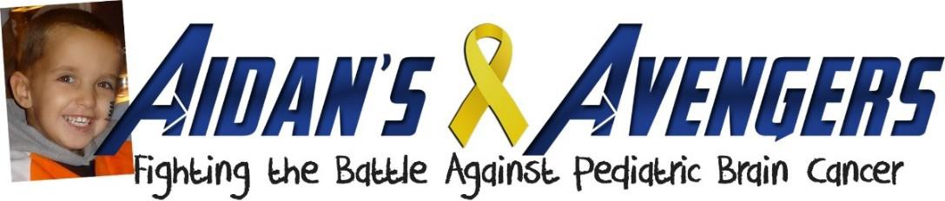

NAME: _______ _ _ _ _ _ _ _ _ _ TEAM: _______ __ _ _ _ _ _ _ __
At some point between Saturday, September 24th and October 1st, I am participating in the 8th Annual Aidan’s Avengers Superhero 5K/1 Mile Walk. This year the event will be held VIRTUALLY. All proceeds benefit Aidan’s Avengers, whose mission is to raise awareness and funding for research programs that focus on Pediatric Brain Tumors (the most deadly form of Childhood Cancer) and provide families with financial support.

I would appreciate your sponsorship of my SUPERHERO efforts in any amount, my personal goal is to raise $ to help fight pediatric brain cancer

Please make checks payable to “AIDAN’S AVENGERS”. If you would like to make an *online donation, please visit AidansAvengers.org/5k select Donate/Sponsor Someone. Please include the runner/walker’s name in the comment box in order for them to receive credit for your online donation. Thank you!

Sponsor’s Name | Email Address | Donation Amount | Cash  √ | Check # | *On-line  $10 MIN.
TOTAL

To learn more about Aidan’s Avengers and their mission, please visit AidansAvengers.org
Aidan’s Avengers is a 501(c)(3) public charity. EIN # 47-2192711

NAME: TEAM: _
Sponsor’s Name | Email Address | Donation Amount | Cash  √ | Check # | *On-line  $10 MIN.
TOTAL
To learn more about Aidan’s Avengers and their mission, please visit AidansAvengers.org
Aidan’s Avengers is a 501(c)(3) public charity. EIN # 47-2192711

NAME: TEAM: _

Please make checks payable to “AIDAN’S AVENGERS”. If you would like to make an *online donation, please visit AidansAvengers.org/5k select Donate/Sponsor Someone. Please include the runner/walker’s name in the comment box in order for them to receive credit for your online donation. Thank you!

Sponsor’s Name | Email Address | Donation Amount | Cash  √ | Check # | *On-line  $10 MIN.
GRAND TOTAL
Aidan’s Avengers is a 501(c)(3) public charity. EIN # 47-2192711

PARTICIPANTS: The runner/walker named above must be registered for the event. Please collect all sponsorship donations prior to the event and contact Aidan’s Avengers at info@aidansavengers.org to arrange delivery. Sponsorship is not required for race participation.

As a thank you for your fundraising efforts, registered/paying participants can receive the prizes based on the amount they raise. Participants only qualify for one incentive level based on total fundraising (excluding initial race registration fees) as of Saturday, October 1, 2022.

SPONSORS: Thank you for helping Aidan’s Avengers in the fight against Pediatric Brain Tumors. To learn more
about Aidan’s Avengers and their mission, please visit AidansAvengers.org

